Description on how to use the same ticker list to download historical daily data from Google Finance and Yahoo Finance:

Sometimes free data sources, such as Yahoo Finance and Google Finance, may have incomplete historical data for a while. It will be good that we can use the same ticker list, and thus the same MetaStock data file folder using the same symbols, to download historical daily data from both Yahoo Finance and Google Finance servers. They can supplement each other. This approach should ensure more complete and timely data to be captured.

Currently, Yahoo Finance has many years of daily data, while Google Finance only provides slightly more than 2 months of data. So Yahoo may be your default server, while Google is used as a backup.

Below is a recommended approach taking advantage of the “MyWebServer” feature on the HSQuote Plus version. Basically, we use the Yahoo Finance symbols in the ticker lists, and intentionally name the ticker files (.tic files) in a manner to maximize flexibility for generic use. You can use the “Yahoo” Server to download historical data from Yahoo Finance, as is done normally. When you prefer to download from Google Finance, just select the “My Web Server (Plus)” Server, and do the download the same way.

We will need to set up the following files in very simple steps described below:
- mywebserver.txt file
- format files: Google_Yahoo1_D1.fmt and Google_Yahoo2_D1.fmt
- ticker lists
- alias_google.csv

Note that we will set up the ticker lists in 2 major groups.
- Group 1 is for US stocks and indexes, which do not have a country suffix, and usually have a prefix of ‘^’ character for indexes. We shall name one ticker list as: “Google_Yahoo1_.tic” to contain all US stocks and indexes. This group only needs 1 ticker list.

- Group 2 is for all the other countries, while Yahoo symbols have a country suffix, Google symbols have a country prefix. For example, for the Australian Securities Exchange (ASX), the symbol for ANZ Banking Group Ltd. is “ANZ.AX” on Yahoo and “ASX:ANZ” on Google. We shall use the Yahoo symbol “ANZ.AX” as the symbol in the ticker list, and embed the Google country code in the name of the ticker list: “Google_Yahoo2_ASX.tic” for the ASX stocks. Similarly, use “Google_Yahoo2_LON.tic” for stocks at London Stock Exchange (LON).

Set-up:

- Copy the following lines and append to your existing “mywebserver.txt”, or simply substitute it with the supplied “mywebserver.txt”.

Google_Yahoo1XXXX,http://finance.google.com/finance/getprices?i=86400&p=250d&df=cpct&q=SSSS,D1,Google_Yahoo1_D1.fmt
Google_Yahoo2_XXXX,http://finance.google.com/finance/getprices?i=86400&p=250d&df=cpct&q=SSSS&x=XXXX,D1,Google_Yahoo2_D1.fmt

- Copy the supplied “Google_Yahoo1_D1.fmt” and “Google_Yahoo2_D1.fmt“ files to the “fmt” subfolder under the Data File Location (indicated on the Preference screen).

- Run HSQuote Plus and set up the Ticker Lists as shown. You may add more ticker lists for other countries, or even for countries that Yahoo does not have data (such as Japan). Of course, you have your own symbols and countries.

US stocks and indexes:

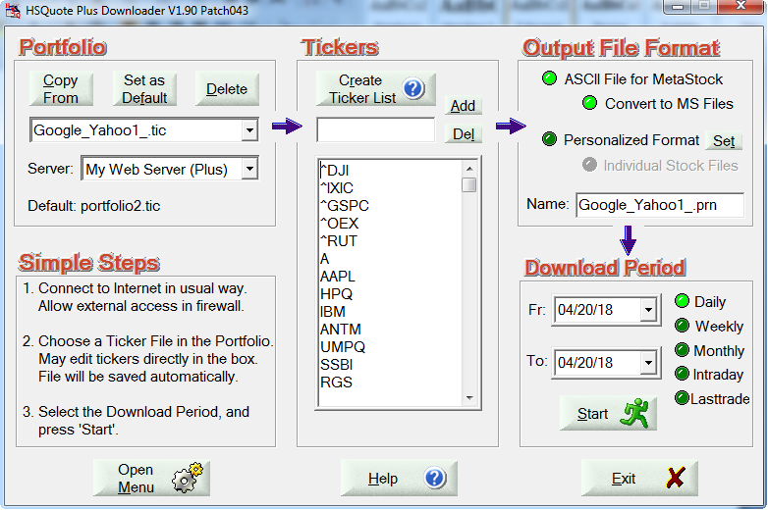
ASX stocks:
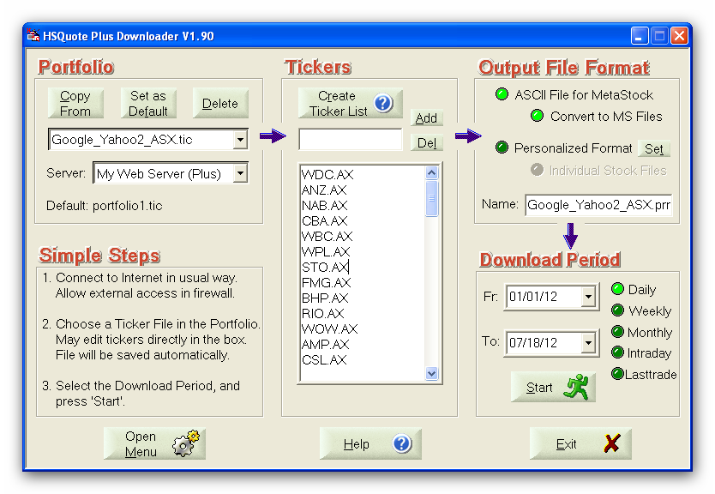

LON stocks:
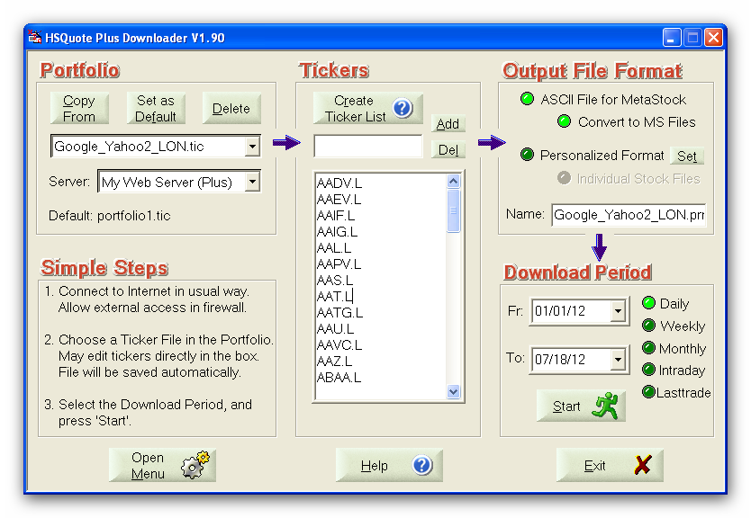
- Copy the supplied “alias_google.csv” file to the HSQuote Plus program installation folder (where quote.exe is located). This is the file that stores the indexes or any stocks which have very different symbols on Yahoo and Google. Double-click this file to open it in Excel spreadsheet. You can see some samples showing Yahoo index symbols in first column, and Google index symbols in second column. You can add more to the list.

Download:

All you need is just select either the Yahoo server of the “My Web Server (Plus)”, choose the download period, and Start downloading normally. Data will be stored using the ticker symbols (Yahoo symbols).

Exchanges with data on Google:

End of day prices provided by SIX Financial Information.
Intra-day data may be provided by Interactive Data Real-Time Services, Inc.
Region | Exchange Code | Description | Delay (minutes)
Americas | BCBA | Bolsa de Comercio de Buenos Aires | 20
 | BMV | Bolsa Mexicana de Valores | 20
 | BVMF | BM&F Bovespa | 15
 | CNSX | Canadian Securities Exchange | Realtime
 | CVE | Toronto TSX Ventures Exchange | 15
 | NASDAQ | NASDAQ Last Sale | Realtime *
 | NYSE | NYSE | Realtime *
 | NYSEARCA | NYSE ARCA | Realtime *
 | NYSEAMERICAN | NYSE American | Realtime *
 | OPRA | Options Pricing Authority Option Chains | 15
 | OTCBB | FINRA OTC Bulletin Board | 15
 | OTCMKTS | FINRA Other OTC Issues | 15
 | TSE | Toronto Stock Exchange | 15
Europe | AMS | Euronext Amsterdam | Realtime
 | BIT | Borsa Italiana Milan Stock Exchange | Realtime
 | BME | Bolsas y Mercados Españoles | 15
 | CPH | NASDAQ OMX Copenhagen | Realtime
 | EBR | Euronext Brussels | Realtime
 | ELI | Euronext Lisbon | Realtime
 | EPA | Euronext Paris | Realtime
 | ETR | Deutsche Börse XETRA | 15
 | FRA | Deutsche Börse Frankfurt Stock Exchange | Realtime
 | HEL | NASDAQ OMX Helsinki | Realtime
 | ICE | NASDAQ OMX Iceland | Realtime
 | IST | Borsa Istanbul | 15
 | LON | London Stock Exchange | Realtime
 | MCX | Moscow Exchange | Realtime
 | RSE | NASDAQ OMX Riga | Realtime
 | STO | NASDAQ OMX Stockholm | Realtime
 | SWX, VTX | SIX Swiss Exchange | 15
 | TAL | NASDAQ OMX Tallinn | Realtime
 | VIE | Wiener Börse | 15
 | VSE | NASDAQ OMX Vilnius | Realtime
 | WSE | Warsaw Stock Exchange | 15
Africa | JSE | Johannesburg Stock Exchange | 15
Middle East | TADAWUL | Saudi Stock Exchange | 15
 | TLV | Tel Aviv Stock Exchange | 20
Asia | BKK | Thailand Stock Exchange | 15
 | BOM | Bombay Stock Exchange Limited | Realtime
 | KLSE | Bursa Malaysia | 15
 | HKG | Hong Kong Stock Exchange | 15
 | IDX | Indonesia Stock Exchange | 10
 | KOSDAQ | KOSDAQ | 20
 | KRX | Korea Stock Exchange | 20
 | NSE | National Stock Exchange of India | Realtime
 | SGX | Singapore Exchange | Realtime
 | SHA | Shanghai Stock Exchange | 1
 | SHE | Shenzhen Stock Exchange | Realtime
 | TPE | Taiwan Stock Exchange | Realtime
 | TYO | Tokyo Stock Exchange | 20
South Pacific | ASX | Australian Securities Exchange | 20
 | NZE | New Zealand Stock Exchange | 20
*Real-time price data represents trades which execute on the NASDAQ and NYSE exchanges. Volume information, as well as price data for trades that don’t execute on those exchanges, are consolidated and delayed by 15 minutes.
Mutual Funds
Mutual fund prices provided by Morningstar.
Region | Exchange Code | Description | Delay (minutes)
Americas | MUTF | USA Mutual Funds | End-of-day
 | MUTF_CA | Canadian Mutual Funds | End-of-day
Europe | MUTF_GB | UK Mutual Funds | End-of-day
Asia | MUTF_CN | Chinese Mutual Funds | End-of-day
 | MUTF_HK | Hong Kong Mutual Funds | End-of-day
 | MUTF_IN | India Mutual Funds | End-of-day
Indexes
End of day prices provided by SIX Financial Information.
Intra-day data may be provided by Interactive Data Real-Time Services, Inc.
Region | Exchange Code | Description | Delay (minutes)
Americas | INDEXBVMF | BM&F Bovespa Indexes | 15
 | INDEXCBOE | CBOE Index Values | 15
 | INDEXCME | Chicago Mercantile Exchange Indexes | Realtime
 | INDEXDJX | S&P Dow Jones Indexes | Realtime
 | INDEXNASDAQ | NASDAQ Global Indexes | Realtime
 | INDEXNYSEGIS | NYSE Global Index Feed | 15
 | INDEXRUSSELL | Russell Tick | 15
 | INDEXSP | S&P Cash Indexes | Realtime
 | BCBA | Buenos Aires Stock Exchange Indexes | 20
 | INDEXBMV | Bolsa Mexicana de Valores Indexes | 20
 | INDEXTSI | Toronto Stock Exchange Indexes | 15
Europe | INDEXBIT | Milan Stock Exchange Indexes | 15
 | INDEXBME | Bolsas y Mercados Españoles Indexes | 15
 | INDEXDB | Deutsche Börse Indexes | 15
 | INDEXEURO | Euronext Indexes | 15
 | INDEXFTSE | FTSE Indexes | Realtime
 | INDEXIST | Borsa Istanbul Indexes | 15
 | INDEXNASDAQ | NASDAQ Global Indexes | Realtime
 | INDEXSTOXX | STOXX Indexes | 15
 | INDEXSWX | SIX Swiss Exchange Indexes | 15
 | INDEXVIE | Wiener Börse Indexes | 15
 | MCX | Moscow Exchange Indexes | Realtime
Asia | INDEXBKK | Thailand Stock Exchange Indexes | 15
 | INDEXBOM | Bombay Stock Exchange Indexes | Realtime
 | SHA | Shanghai/Shenzhen Indexes | 1
 | INDEXHANGSENG | Hang Seng Indexes | Realtime
 | HKG | Hong Kong Stock Exchange Indexes | 15
 | KOSDAQ, KRX | Korea Stock Exchange Indexes | 20
 | INDEXNIKKEI | Nikkei Indexes | 20
 | INDEXTYO | Tokyo Indexes | 20
 | INDEXTYO:JPXNIKKEI400 | © Japan Exchange Group, Inc., Tokyo Stock Exchange, Inc., Nikkei Inc. | 20
 | INDEXTOPIX | Tokyo Stock Exchange Indexes | 20
 | IDX | Indonesia Stock Exchange Indexes | 15
 | NSE | National Stock Exchange of India Indexes | Realtime
 | SHE | Shenzhen Stock Exchange Indexes | Realtime
 | TPE | Taiwan Stock Exchange Indexes | Realtime
Middle East | TLV | Tel Aviv Stock Exchange Indexes | 20
 | TADAWUL | Saudi Stock Exchange Indexes | 15
South Pacific | INDEXASX | Australian Securities Exchange S&P/ASX Indexes | Realtime
 | INDEXNZE | New Zealand Exchange Indexes | 20
Bonds
Region | Exchange Code | Description | Delay (minutes)
United States |  | KCG Bondpoint | 15
Currencies
Region | Exchange Code | Description | Delay (minutes)
Global | CURRENCY | SIX Financial Information | 3
 | CURRENCY:BTC | Coinbase, Inc. | 3

