Description on how to download historical daily data from Bloomberg:

Up to 6 years of historical End-Of-Day data for various countries are available at Bloomberg. For example, Arab Bank of Jordan data can be fetched at:

http://www.bloomberg.com/apps/data?pid=webpxta&Securities=ARBK:JR&TimePeriod=6Y&Outfields=HDATE,PR005-H,PR006-H,PR007-H,PR008-H,PR013-H

For quicker download and only most recent one week data are required, the TimePeriod may be changed to 1W (1 week).

http://www.bloomberg.com/apps/data?pid=webpxta&Securities=ARBK:JR&TimePeriod=1W&Outfields=HDATE,PR005-H,PR006-H,PR007-H,PR008-H,PR013-H

Set-up:

- Copy the following line and append to your existing “mywebserver.txt”, or simply substitute it the attached “mywebserver.txt”.

Bloomberg_XXXX,http://www.bloomberg.com/apps/data?pid=webpxta&Securities=SSSS&TimePeriod=6Y&Outfields=HDATE%2cPR005-H%2cPR006-H%2cPR007-H%2cPR008-H%2cPR013-H,D1,Bloomberg_D1.fmt

Or the following for just 1 week data:
Bloomberg_XXXX,http://www.bloomberg.com/apps/data?pid=webpxta&Securities=SSSS&TimePeriod=1W&Outfields=HDATE%2cPR005-H%2cPR006-H%2cPR007-H%2cPR008-H%2cPR013-H,D1,Bloomberg_D1.fmt

- Copy the “Bloomberg_D1.fmt” file to the “fmt” subfolder.
- Run HSQuote Plus and set up the screen as shown.

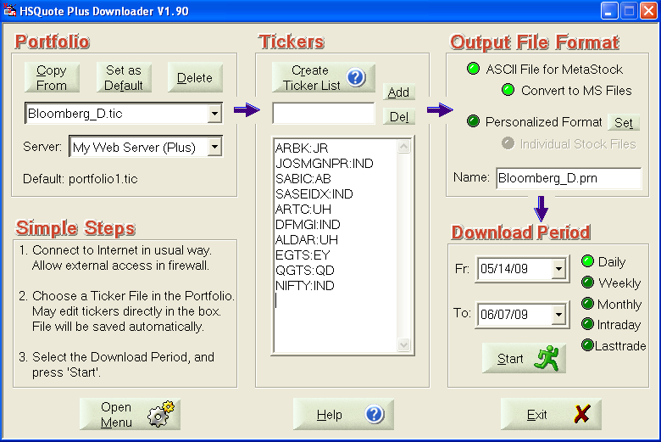

Historical Daily Data Download:

Just specify the Download Period Fr. and To. dates (take note that only 6 years of most recent historical data are available.)

Again, to speed up download process and when you do not need 6 years of data, you may change the TimePeriod parameter in mywebserver.txt file to 1M or 1W, etc. Not all time periods are available, and you will need to test it out.

