Description on how to download backfilled intraday data from Google Finance:

Google Finance provide free intraday data for the US market, up to 15 days. For example, the following URLgives 15 days of backfilled intraday 60 seconds (1 minute) data for IBM:

http://www.google.com/finance/getprices?i=60&p=15d&df=cpct&q=IBM

We can use such data to package 1-min, 5-min, 6-min, 10-min, 20-min, 30-min, or 60-min intraday data.

Set-up:

- Copy the following line and append to your existing “mywebserver.txt in the HSQuote program installation folder.

Google_IXXXX,http://www.google.com/finance/getprices?i=60&p=15d&df=cpct&q=SSSS,I1,Google_Intraday_I1.fmt

- Copy the “alias_google.csv” file to the HSQuote program installation folder.
- Copy the “Google_Intraday_I1.fmt” file to the “fmt” subfolder under the Data File location.
- Run HSQuote Plus and set up the screen as shown. You may have other portfolios called “Google_I30.tic”, “Google_I60.tic”, etc.

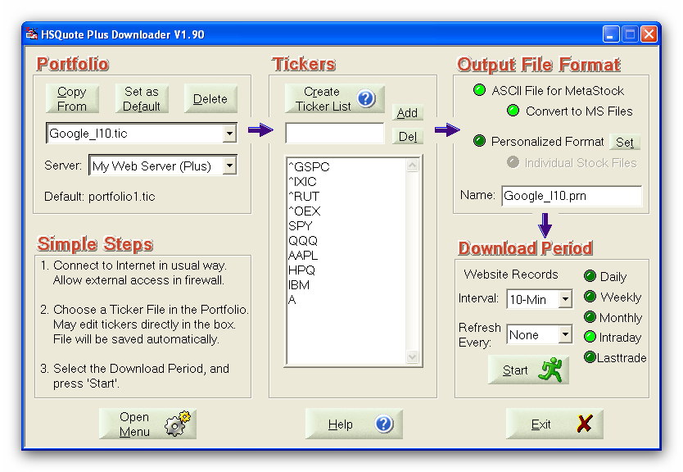
Backfilled Intraday Data Download:

For the first time download, you may click on the “Daily” option, and change the Fr. Date to 1 month back, and then switch back to the “Intraday” option. This will allow capturing up to 15 days of backfilled intraday data from Google Finance.

HSQuote program will keep track of the last successful data date. You don’t need to indicate the starting period of the date range. Just leave the Intraday option selection, and click the Start button to download data.

