Description on how to download Historical NSE data from nseindia.com:

Individual historical daily data for NSE equities may be downloaded from http://www.nseindia.com/archives/archives.htm in .csv format. A bhavcopy downloader tool (eg. from http://www.getbhavcopy.com/) can also be used to download such daily data in .txt format.

Below describes a method to extract data from the .txt files downloaded by getbhavcopy downloader, which have the following data format:

<ticker>,<date>,<open>,<high>,<low>,<close>,<volume>,<o/i>
20MICRONS,20111005,52.45,53.8,51.3,53.25,154636,0
3IINFOTECH,20111005,26.25,26.25,24.95,25.05,734649,0
3MINDIA,20111005,4098.95,4249.9,4070,4200.25,570,0
A2ZMES,20111005,205,210,200.7,202.1,49080,0
AANJANEYA,20111005,397.1,415,390.15,402.7,82372,0
AARTIDRUGS,20111005,104.5,104.5,101.1,102.75,740,0
AARTIIND,20111005,45.5,46.4,45.3,45.55,11846,0
AARVEEDEN,20111005,35.15,35.15,33.9,33.9,101,0
ABAN,20111005,344.8,345.2,335,337.75,525985,0
ABB,20111005,694.95,694.95,663.35,670.6,104454,0

Set-up:

- Copy the following lines and append to your existing “mywebserver.txt”, or simply substitute it with the attached “mywebserver.txt”. (Assume the data file folder is located in I:\My Projects\HSQuote Data\. Users may need to change the path accordingly.)

nseindia_D,I:\My Projects\HSQuote Data\nseindia_D\YY4Y-MM1M-DDDD-NSE-EQ.txt,D4,nseindia_D4.fmt

- Copy the “nseindia_D4.fmt” file to the “fmt” subfolder within the Data File Folder.
- Run HSQuote Plus and set up “nseindia_D.tic” as shown. Note that there is no need to enter symbol names as the format file will automatically retrieve and renew the list before downloading data.

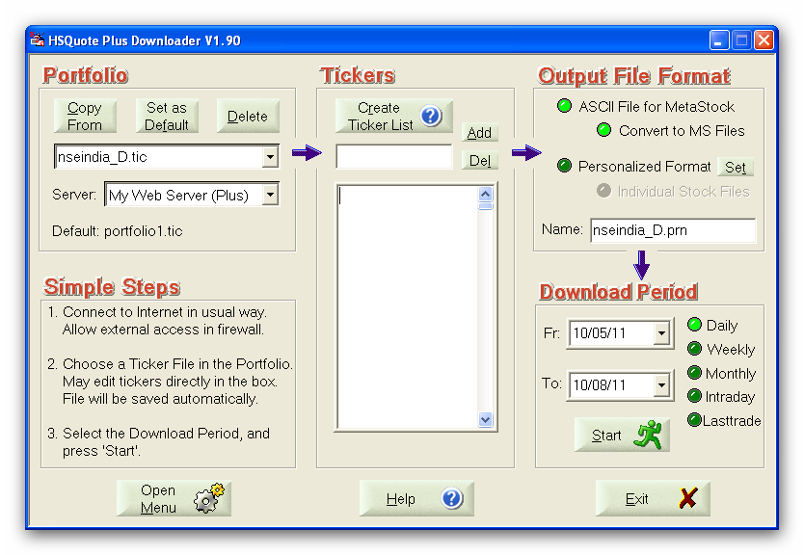

Historical Daily Data Download:

- On a daily basis, store the .txt file in the folder I:\My Projects\HSQuote Data\.
- Run HSQuote Plus, set the To: date to the date of the download file.
- Select Daily, and click on the Start button. Download will start.

Note that getbhavcopy downloader can download historical daily data files for a period at one time. For the first time when data for a historical period are to be extracted, that is, to download data from the Fr date to the To date, the following modifications can be modified:

- Change the line in mywebserver.txt to:
nseindia_D,I:\My Projects\HSQuote Data\nseindia_D\yy4y-mm1m-dddd-NSE-EQ.txt,D4,nseindia_D4.fmt

- Open the nseindia_D4.fmt file and add a ‘1’ in front of the myDownloadAllHistoricalDailyData line, that is:
1@myDownloadAllHistoricalDailyData#Auto process single day Daily data download from Fr Date to To Date (default: 0, No)

